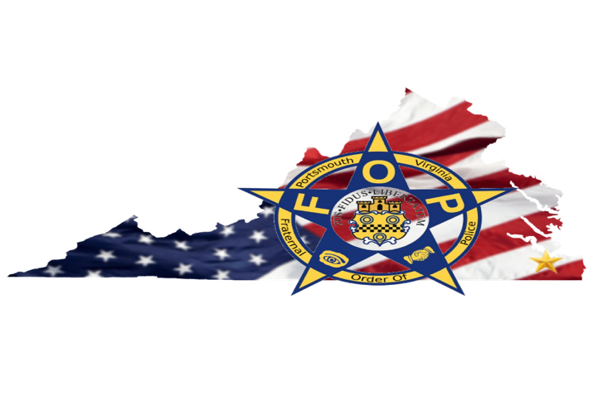

***PRESS RELEASE***

***Portsmouth Virginia Gosport Lodge No. 20***

For Immediate Release: August 30, 2021

**PORTSMOUTH F.O.P. CALLS FOR CITIZENS TO STAND UP EXPRESS CONCERN ON THE CURRENT STATUS OF THEIR PUBLIC SAFETY ORGANIZATIONS**

PORTSMOUTH, Va. - Citizens of Portsmouth, the Fraternal Order of Police, Gosport Lodge No. 20, wanted to make you aware that effective Saturday, August 21, 2021, the Portsmouth Police Department had no choice but to reduce the number of services offered to their citizens to increase the number of officers working in their Uniform Patrol Division. Because of this immediate need for additional officers, every Portsmouth citizen will now be without a fulltime Strategic Traffic Unit, School Resource Officer program, and Street Crimes Unit. Although the appearance of losing these units may not seem impactful to the community at first, we would like to reiterate the importance and need for each of these three units.

First, the Strategic Traffic Unit is a specialized unit with a specific skill set that most officers do not generally possess. Understanding traffic laws and writing traffic citations for moving violations just touches the surface of what this unit does for the community. These officers are entrusted with ensuring all tow companies and taxi companies are licensed and operating within the law. In addition, these officers investigate hit and runs as well as serious and fatal vehicle and pedestrian accidents within the city lines and reconstruct the circumstances that led up to and caused the accident. These officers also complete traffic assessments in problematic areas while investigating the need for additional traffic signage or signals and present their findings to city engineering. Lastly, these officers provide a much-needed service to those in mourning by escorting funerals through the city to ensure they make it to their loved one’s final resting place safely. If these officers are no longer able to provide these services to the city, who will?

Next, the School Resource Officer Unit is a specialized unit that not only requires a special officer with a special skill set to fill these positions, but also requires specific specialized training per the Virginia Department of Criminal Justice Services. These officers are a critical part of community policing and school safety within the City of Portsmouth. These officers interact, mentor, and assist troubled and at-risk youth within the City of Portsmouth with the goal of helping them achieve their dreams and greatness within society. In addition, they support school programs and offer a sense of safety and security for all who attend or work within the school. Without these officers present, parents would feel less at ease when sending their children to attend school each day for fear of something terrible happening.

Lastly, the Street Crimes Unit, a specialized unit aimed at identifying, curtailing, and preventing high profile crimes, no longer exists. These officers, who serve as a quick response team to violent crime that has just occurred, or work based on intel that proffers that a crime may or is likely to transpire, seek to prevent crime from happening or escalating, while focusing on saving lives. This unit has been successful at not only getting large amounts of illegal drugs off the street but also by getting dozens of illegal and stolen firearms out of the hands of those who wish to use them in the commission of another crime.

The Portsmouth Fraternal Order of Police has spoken to city management in reference to recruitment and retention and the only response we have received is that “we are working on it.” As a result, this organization believes that now is the time for action by the citizens of Portsmouth. Citizens of Portsmouth, we call upon you to demand that city leadership to not only recruit and retain professional qualified officers to work within the Portsmouth Police Department, but to pay its current police officers a better salary commensurate with experience and offer bonuses to help keep their experience in Portsmouth. We need to stop the “bleed” of officers leaving the city to provide their law enforcement experience to surrounding jurisdictions such as the cities of Virginia Beach, Norfolk, Chesapeake, and Newport News because they want to feel valued by their city leadership. Across the county, police with higher staffed and highly experienced police officers can have a better relationship with the community and together can help address the rise in crimes such as gun violence with the youth. However, if our officers keep leaving there will be no one for the community to partner with and no public safety experience to help combat the violence affecting the city. We as an organization implore you to raise your voice loudly so that your concerns are heard and can no longer be ignored by the governing leadership in the City of Portsmouth. Say it loud and let them know enough is enough! Your police agency and your neighbors need your help.

Very Respectfully,   
Ron White President  
Fraternal Order of Police, Gosport Lodge No. 20