**City of Norfolk**

Mayor Kenneth Copper Alexander

State of the City Address – 2022

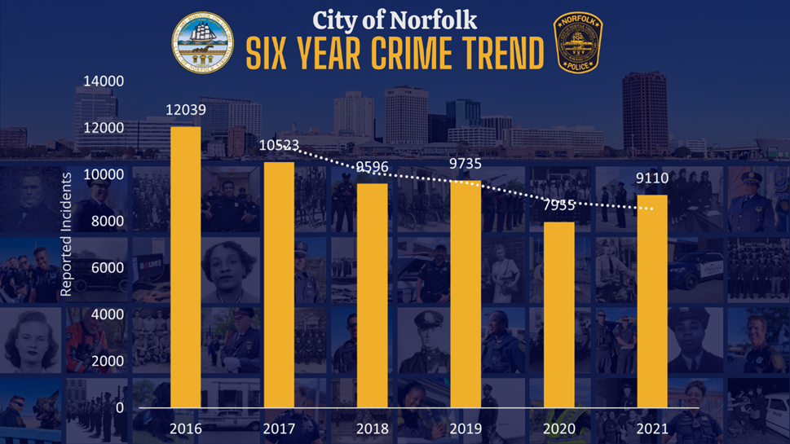

Reported Incidents:

In 2021, the Norfolk Police Department responded to **210,502** calls for service. Out of those calls, **9,110** were reported and investigated as criminal incidents. Since 2016, the number of reported incidents has decreased by **24%** and has continued to trend downward into 2022.

**Norfolk Police Department Highlights**

**NPD LIVE VIRTUAL COMMUNITY POLICING**

The climate of civil unrest and the COVID-19 pandemic in early 2020 presented new challenges to the Norfolk Police Department: how to keep staff members safe and well, and how to do it while continuing to a providing a high level of service.

The innovative Telephone Reporting Unit (TRU), launched on March 23, 2020, allowed officers to take reports requiring sworn officer expertise, knowledge of departmental policies and Virginia law over the telephone.

Inspired by the success of the TRU, Chief Larry D. Boone directed staff to implement a more interactive option for citizens accustomed to having officers respond to their homes and businesses, to take routine reports. Insistent that technology could allow citizens to interact with an officer, he tasked the department’s Technology Support Unit (TSU) with developing a platform.

In October 2020, NPD created the first virtual law enforcement response program in Hampton Roads to help reduce employee and citizen exposures to COVID-19. This program continued into 2021 offering citizens the opportunity to speak with an officer "virtually" regarding non-emergencies. This service allowed officers on the street to remain available for emergencies. In 2021, the Telephone Response Unit handled **8,262** calls for service.

The program continues to expand as more citizens become aware of the options available to them, and the Norfolk Police Department intends to continue, even in the post pandemic and police reformed world.

**Hispanic Citizen Engagement and Outreach**

**In October 2021,** Norfolk Police and Hispanic media outlets Hosanna and La Selecta radio stations, and the local newspaper Hispanos De Valor, collaborated for its annual Hispanic Day Awareness and Fiesta at Ocean View Park. A dozen Hispanic and Spanish language speaking officers engaged hundreds of Hispanic residents and led the *first* community parade to kick-off the day’s activities and outreach event.

**F.U.T.U.R.E- Fellowship of Understanding Through Unified Relationships and Engagement**

The Norfolk Police Department introduced an initiative for youth*,* also known as **F.U.T.U.R.E.** Officers believed that youth who witnessed much of the social protests and protestors that poured onto the streets of the world, via television and social media news-trend feeds, often saw law enforcement officers through a negative lens. These youth needed an outlet to ask questions, or simply talk about their experiences or impression of police. This monthly, virtual engagement initiative for dialogue was created to develop mutual respect and understanding, and to help relieve some of the rigidities of virtual learning fatigue, through conversations with officers. Officers conduct a virtual check-in with students at Park Place Elementary, a school located in an underserved community for a dynamic hour of questions and answers. The questions from students are often complicated and very direct; yet allows for courageous, age-appropriate discussions. Officers authentically and enthusiastically answer students’ questions to further improve and strengthen relations with Norfolk’s youngest and most vulnerable citizens.

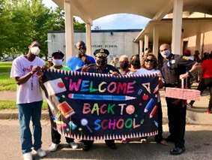

**We Care Project**

During the pandemic and still to this day, The Norfolk Police Department works in tandem with the Norfolk grassroots organization, Seniors Aging Gracefully, (SAG), or “We Care Project,” to pack and deliver groceries and personal protective equipment weekly to over 140 senior citizen residents.

Officers learned during their deliveries that Norfolk senior citizens are greatly affected by isolation, underlying health conditions, and lack of computer-technical knowledge. These challenges often complicated what was once consistent and normal human physical interactions, prior to the pandemic. Throughout this outreach, the officers continue to develop closer relationships with Norfolk’s senior community and learned from the senior citizens served that other senior were also in need of food deliveries. Those identified senior citizens are now included in this initiative and receive weekly food deliveries with a brief yet beneficial and enthusiastic safe interaction with NPD officers.

Additionally, since September 2020, Officers conduct weekly check-in phone calls to dozens of senior citizens at two assisted-living facilities, Suburban House and Grandy House. During the calls, officers engage residents about their day and any concerns they may have. The phone calls serve as another layer of intentional supportive outreach, to bring friendly engagement where isolation or loneliness may occur with some of Norfolk’s senior population. Seniors welcome the weekly calls and officers find the connection especially gratifying as the seniors are encouraging and often share the wisdom of their years.

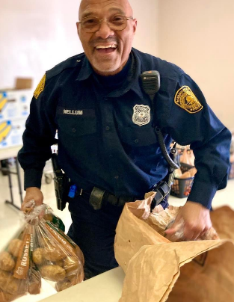

**Covid-19 Vaccine Outreach**

In 2021 The Norfolk Police Department partnered with Hampton University, and city agencies to co-host several vaccine and vaccine registration opportunities throughout the city to include at-risk communities. This was important in keeping infection and hospitalization numbers down.

**Life Enrichment Center** - Norfolk officers continued to support education through Police Leadership Unveils Success (PLUS), literacy tutoring in Norfolk Public Schools Title-I elementary schools. This was done in-person and virtual throughout 2021.

**Holiday Toy/Food Drive** - Norfolk Police hosted a 6 - week toy drive to support youth of incarcerated parents, disabled youth, and youth in at-opportunity communities. Dozens of youths were treated to toys and essential items thanks to the citizens of Norfolk, the Norfolk Police Foundation, and Department of Justice.

**Senior Citizen Transportation Outreach** - Organic conversations in 2021 between officers and Norfolk seniors regarding daily independence and mobility, led to securing hundreds of Hampton Roads Transit (HRT) monthly and Handicap-Ride passes. The passes will be distributed to seniors throughout the City of Norfolk, Spring 2022.

**ATF Partnership** – The National Integrated Ballistic Information Network (NIBIN) Program automates ballistics evaluations and provides actionable investigative leads in a timely manner. NPD Detectives, enter cartridge casing evidence into the BrassTRAX System, thus giving the NPD a timely response about cartridge casing evidence from our jurisdiction, neighboring ones, and others across the country. The NPD has assisted other agencies such as the Virginia State Police and Portsmouth Police with entering cartridge casing evidence related to their investigations. As to the NPD’s NIBIN program, between January 1, 2021, and December 31, 2021, the NPD Forensics Unit examined and triaged **5313** cartridge casings. This is the process to determine which cartridge casings have requisite value for NIBIN association. Of those, **1350** cartridge casings were entered into BrassTRAX for submission to ATF. **312** of those have generated NIBIN association leads per ATF correlation exam.