**Social Media – Cold Case blast February 2024**

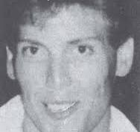

**Brian Pettinger**

**1 February 1988**

On February 1st, police responded to Eclipse in reference to a body that was found floating in the James River off of River Shore Road by two watermen. Jewelry left on the body helped to identify him as Brian Craig Pettinger. Brian was partially clothed and had been tied up. Family reported him missing on December 4th 1987 in Newport News. He was last seen on December 2nd at a dance studio in Hampton. It was believed that Brian had been in the water for several weeks, possibly months. An exhaustive investigation by multiple jurisdictions did not result in any arrests.

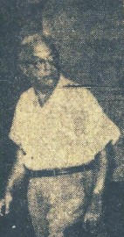

**Myer Jacobson**

**9 February 1963**

Around midnight on February 9, 1963, Myer Jacobson 54, went to the Portsmouth Deer and Hunt Club on Shoulders Hill Road, in what was then Nansemond County. The club was a known gambling establishment. Prior to his arrival, three suspects entered, robbed a dozen patrons and held them in a back room. After surprising Myer when he entered, he resisted and was shot in the chest. The suspect accidentally shot an accomplice during the shooting as well. Myer died on scene. The Virginia State Police conducted the homicide investigation with the assistance of the F.B.I. and multiple surrounding jurisdictions. Several subjects were investigated but no suspects were identified.

No Photograph available

**Ernest Harris**

**23 February 1993**

On February 23rd 1993, Ernest Harris 40, was at home recovering from a recent surgery. He was alone watching television when an unknown suspect/s kicked in his front door and shot him once. They stole a portable “boom box” radio and left Ernest to die. Family returned from a movie night and found Ernest dead in the living room. More than three dozen people were interviewed but not enough information was obtained to make an arrest.

No Photograph available

**Marion Reid**

**25 January 1990**

The morning of Sunday February 25th, family and neighbors, checked on Marion Reid 81, in Chuckatuck. Marion lived alone and was elderly but beloved. She was found dead on the floor of her small semi-secluded home. Her last contact by phone was with family the day before. Marion was found bound with multiple injuries and had been sexually assaulted. Detectives conducted dozens of interviews and collected physical evidence. Unfortunately, multiple examinations and re-submissions of evidence have not produced information for any suspect arrests.

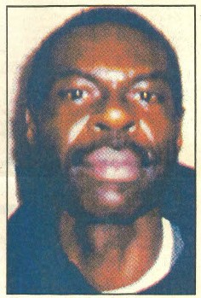

**Cleophus Norfleet**

**27 February 1997**

An officer conducting a patrol check in the area of Babbtown Road on February 27, 1997 at about 0235 hrs. observed a parked vehicle at a gate securing the Camp’s path. The officer found the vehicle owner, Cleophus Stanley Norfleet Jr. 46 yrs. old, deceased with multiple gunshot wounds. It is believed “Stan” owed money to someone and there had been recent confrontation between them. Very little evidence and information was obtained. The investigation did not lead to any arrests.

Anyone with information in any of these cases is asked to contact ***Suffolk Police or Suffolk Crime Line***. To submit online, go to ***www.p3tips.com***, visit the *Suffolk Police Department* website (***www.suffolkva.us/spd***) and look for the *Suffolk Crime Line* link, or go to the *Suffolk Police Department Facebook* page. You can also call **888-LOCK-U-UP, 1-888-562-5887**, Option 5. Once a person submits a tip, they will be given a TIP ID and password. With this information they can login at p3tips.com and submit follow-up information, engage in two-way dialogue, be informed of the outcome of the tip, and access any pertinent reward information.